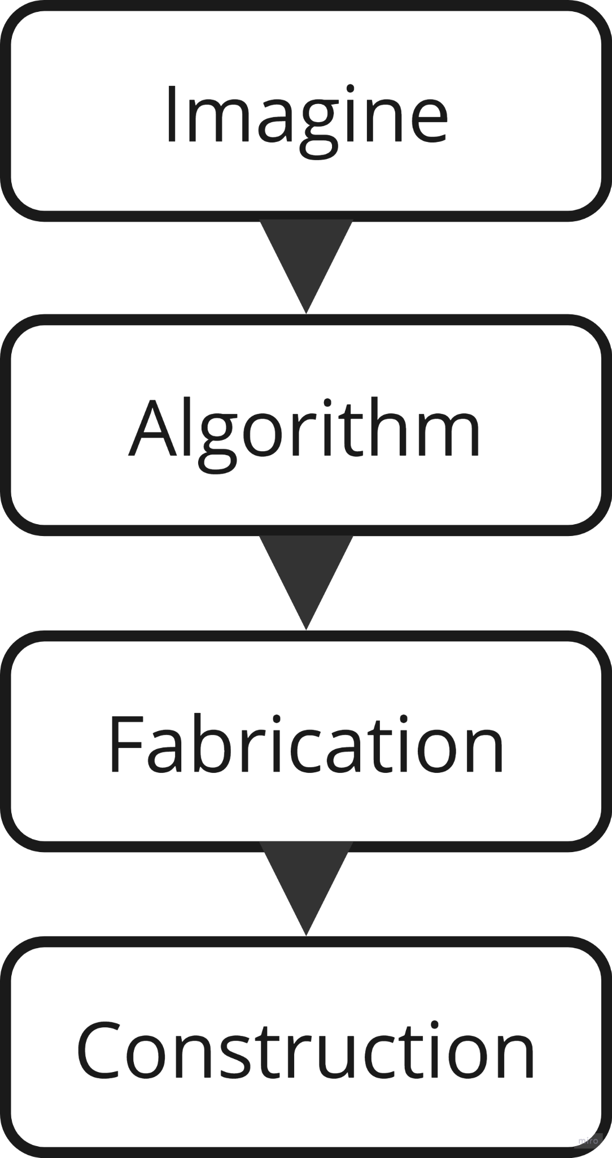
0626 / WORKFLOW STATUS
recorded by 02:59
Imagine Team
Cracking/Holey/Narrow planks

Algo Team

Fabrication Team

Constructrion Team
Can’t find The suitable fittings for two wooden panels
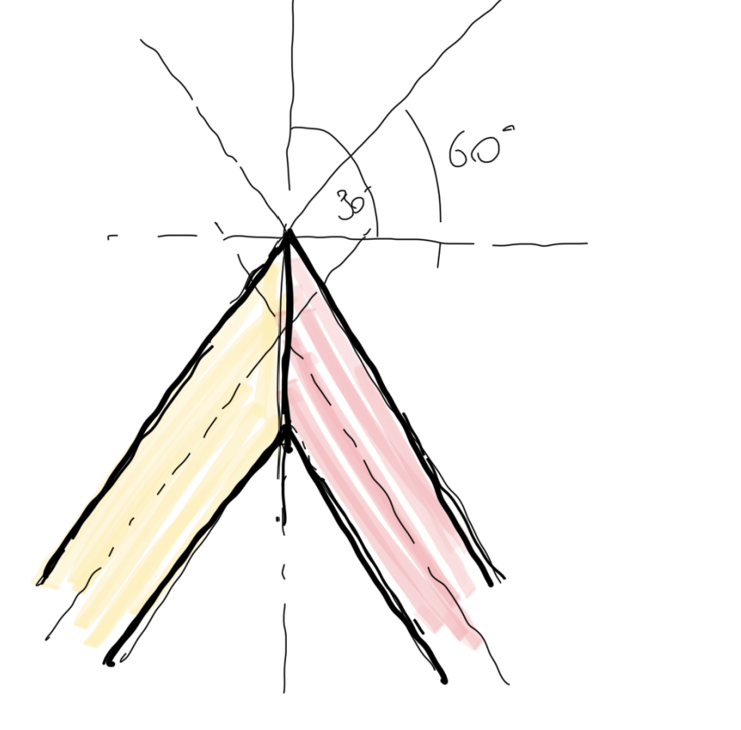
Material Requirement
- KUKA robotic arm
- Milling head tool for robotic arm
- DC Camera
- Tripod
- Raw Wooden Slice 3.5m
- LED strip 3.5m in Length
- Fixed Panel
- Color Tape (For calibration)
- Marker
SoftwareRequirement
- Google colab platform
- Autocad

IMAGING MANUAL
- screwing**
  - Use screws to nail the log to the bottom laminate, with one end of the log in focus with the frame centre line to prevent errors caused by warping of the timber
**If the timber is sufficiently flat
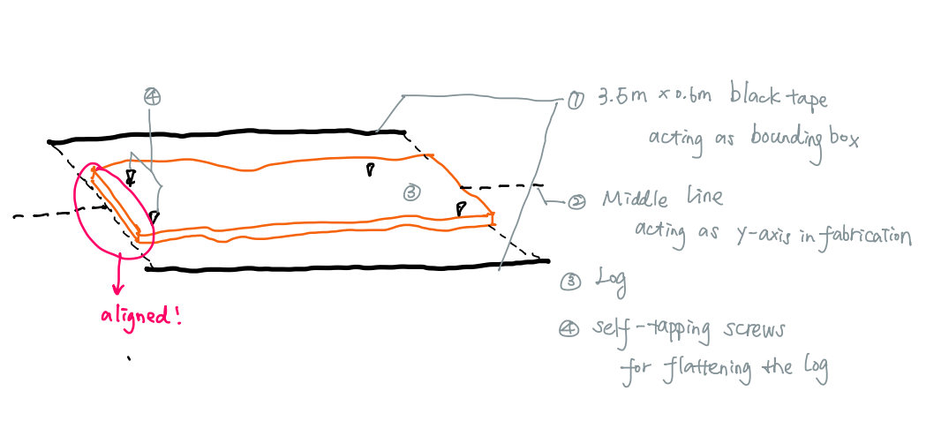

- labeling
  - middle point of the boundary box painted on the both ends of the log
  - the bottom of the bounding box as axis X →| direction
  - number 01,02…
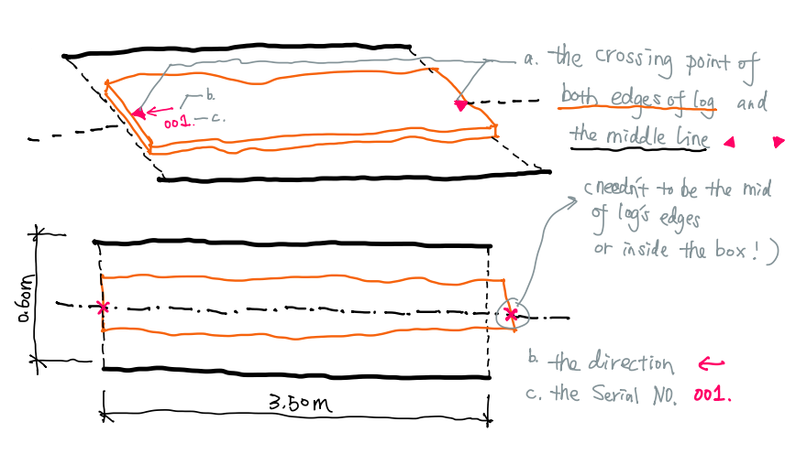

- photo
  - align the middle point and middle line of the boundary box with the camera’s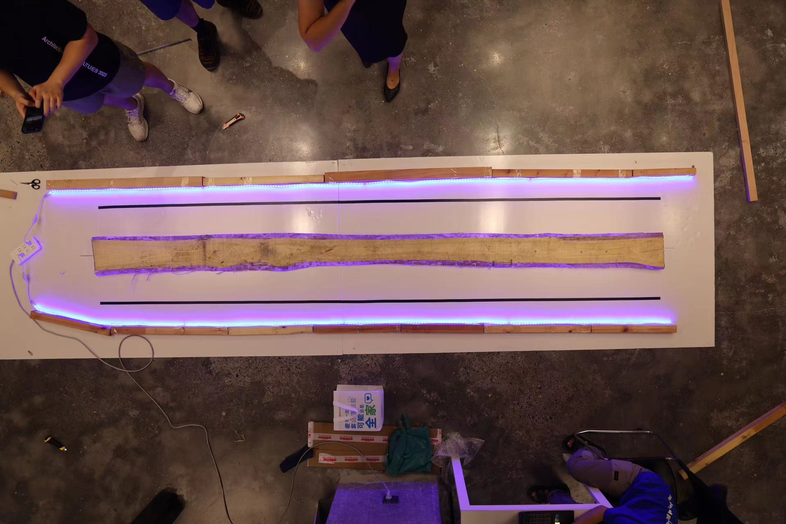

- imaging
  - Elimination of distortions
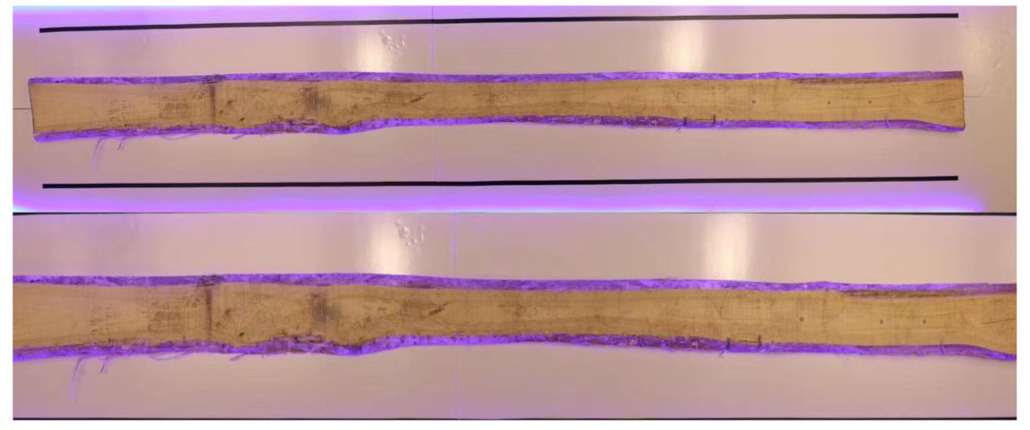
  - segmentation(with RGB)
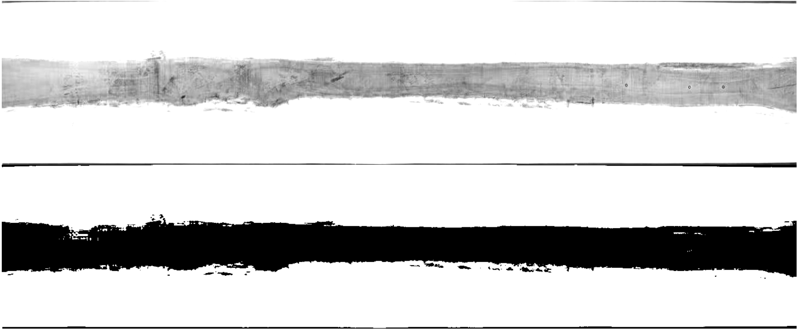
  - masking
  - denoising

  - apply a boundary box and middle line (.dxf)
output:
A mask (.png) for Algo group to calculate the area

A boundary box and middle line (.dxf) for DXF group to locate the Origin Point and X axis

ALGORITHM MANUAL
- Input
a. A mask (.png) for Algo group to calculate the area

- Algorithm
a. Get the graphs that are put together with minimum overlap.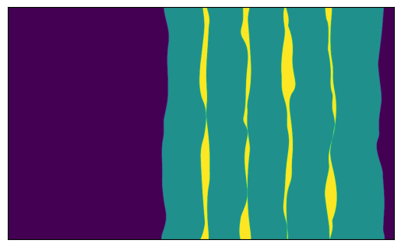
b. txt describe with numbers, orientation, and minimum consumption—construction group
eg：
Best Solution: [[2, 1, 0, 3, 4], [-1, 1, -1, 1, 1]]
Best Cost: 13372
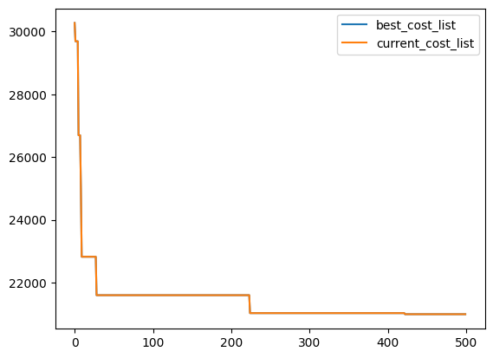

- Line
a. Data - Geometry: Calculate the overlap of each two plates separately based on the resulting best solution to obtain the cutting line.
b. optimize the cutting line
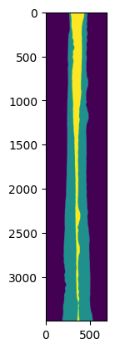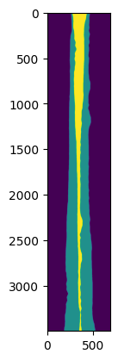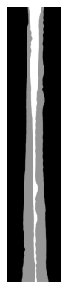

- Output
a. black and white imagine(.png) for dxf group to extraction of cutting line(dxf)

DXF MANUAL
1. File preparation
A dxf file named “DF_XXX.dxf” (XXX stands for the ID of the board) should be provided for each board. The content is illustrated here:
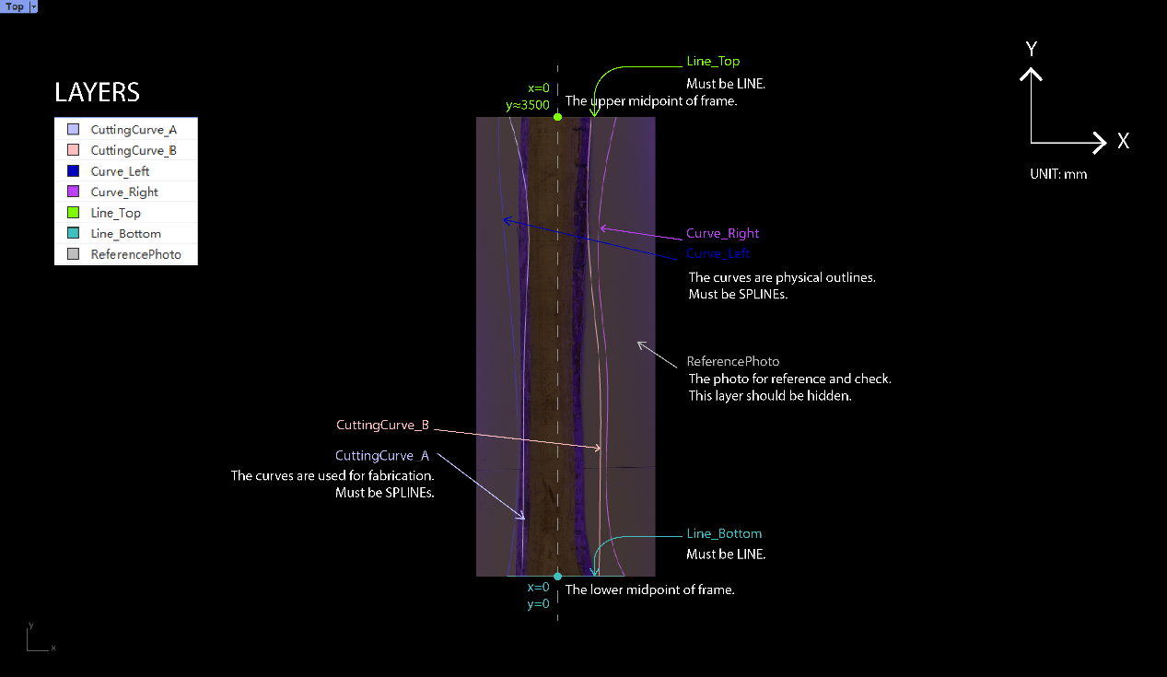
The exact content example without any illustration is shown here:
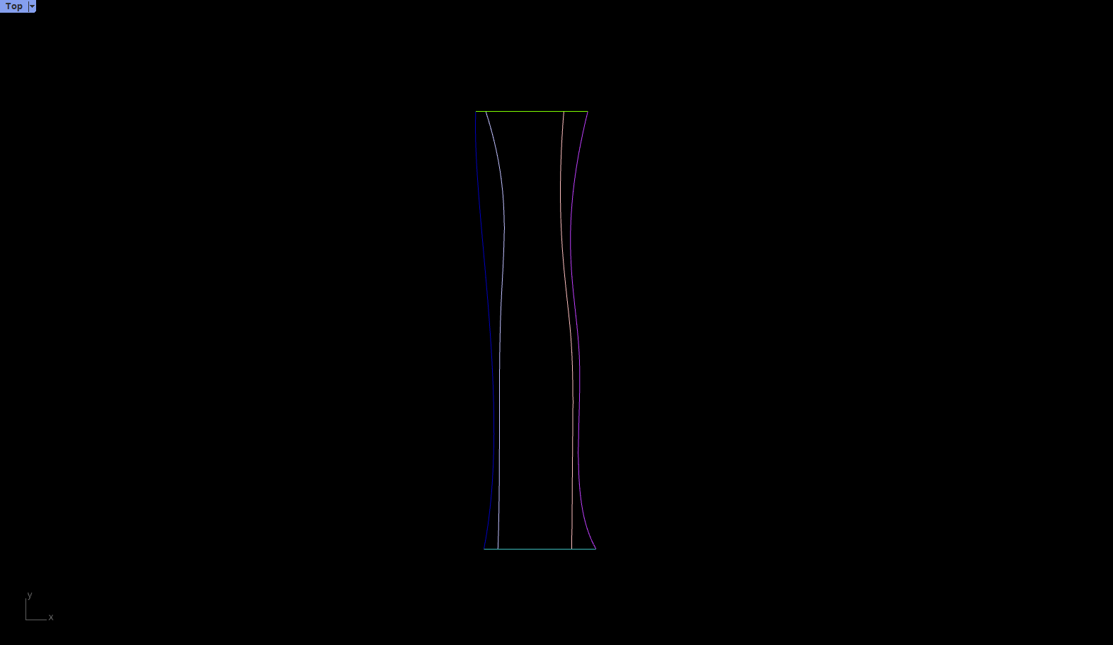
The example dxf file is attached.

2. Output
optimize the dxf,clarify information the Fabrication group need:
2OriginalLine of plank, 2CuttingLine,2LocatingPoints(Top&Bottom),Reference Photo

FABRICATION MANUAL

1. Board preparation
Each board should be marked two section middle points, an arrow, and an ID before sent for fabrication. The arrow points to the origin point. The ID should be compatible with the digital file name.


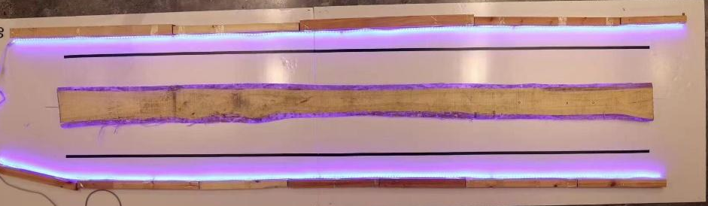
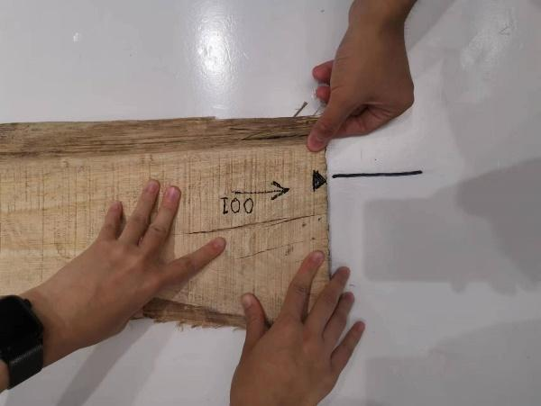
Triangle marker on the edge
Arrow pointing to the origin and ID

2. Board positioning
The coordinate system is drawn on the fabrication table illustrated in yellow. The origin point or the board should be overlapped to the origin point on the fabrication table. Then the other middle point should lie on the axis drawn.



3. Board fixing
Self-tapping screws are used to fix the boards. Each board needs three or more self-tapping screws that are non-colinear. The number of screws dependents on the flatness of the board.
4. Start milling
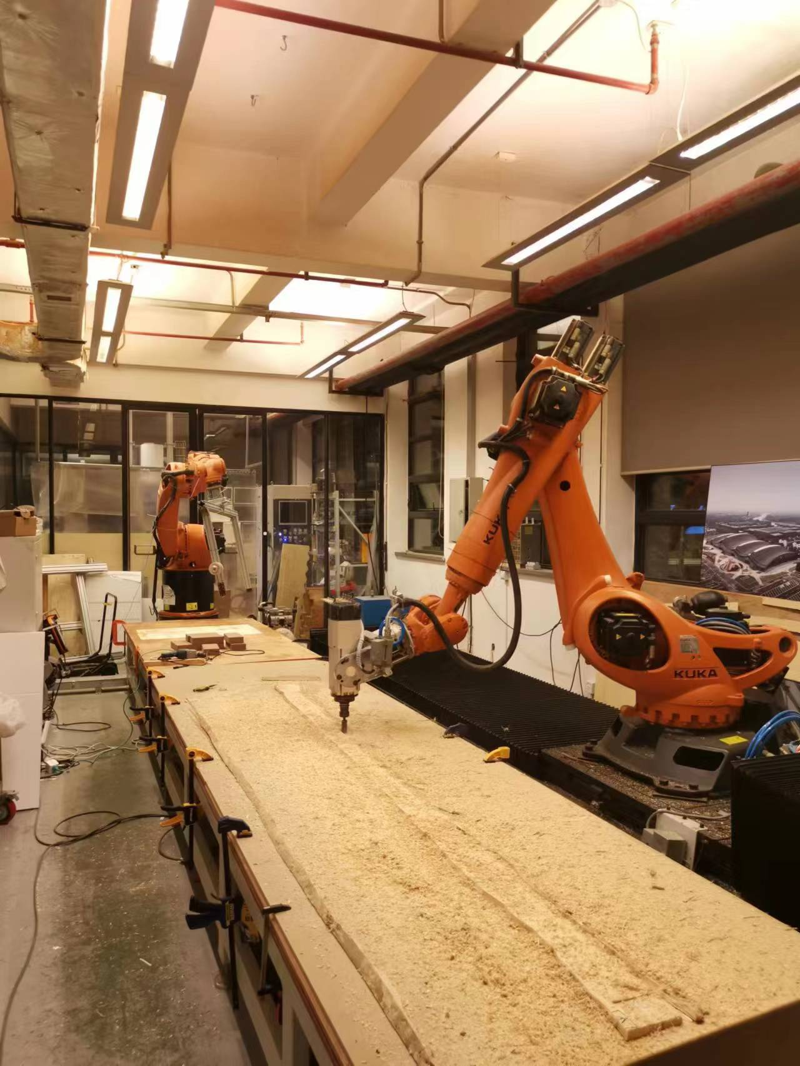
The fabrication team will do the milling. The steps are listed below as a reminder.
- Switch on the power of the miller and the fan simultaneously.
- Save necessary files in a USB and plug in to the controller.
- Switch to expert user group (pwd: kuka)
- Copy src file to KUKA.
- Press the file, click “select”
- Check E1=3594.03, E2=720 in the src file.
- Turn on the milling motor: Menu - Display - Inputs/outputs - Digital I/O - Output - 16 - Value (hold down left safety button) - close
- If the miller is not heated up, let the fan run for two minutes.
- Switch to automatic mode.
- Set a proper speed, and press the start button.
5. Board removal
Steps to remove the board:
- Turn off the drilling motor.
- Take out the screws.
- Remove the board.
- Clean the table.
5. Safety Spec

CONSTRUCTION MANUAL
Construction Issue
- Panel Joint Solution
- The Fitting of the joint

